

**Parking on the Riverfront for Gateway Arch Riverboats**

* ***Levee parking located off of South Leonor K. Sullivan Blvd. between Poplar Street and the Gateway Arch Grand Staircase.***
* ***Allows for ADA accessible path for those visiting the Gateway Arch Riverboats.***

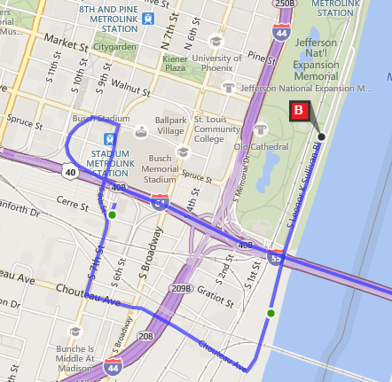

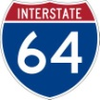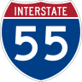

**From Illinois: Poplar Street Bridge**

Heading WEST on the Poplar Street Bridge, continue on Interstate 64 West. Take exit 40A toward Stadium/Tucker Blvd. Turn RIGHT on Clark St then turn RIGHT onto 7th Street. Turn LEFT on Chouteau Ave. Continue EAST on Chouteau, make a LEFT on 1st Street. At Poplar, make a RIGHT, then turn LEFT on Lenore K. Sullivan. Levee parking will be immediately on your RIGHT.

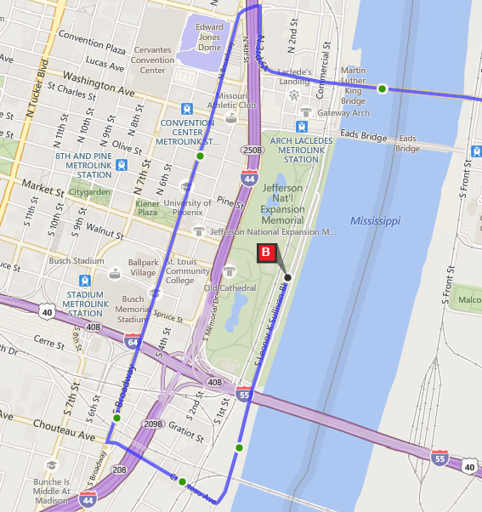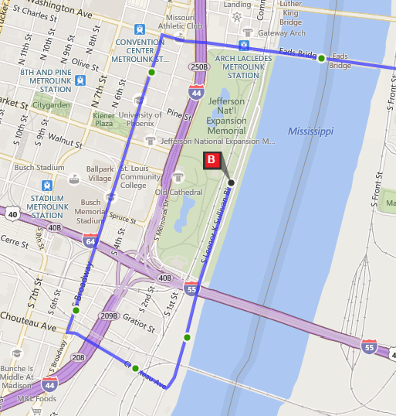



**From Illinois: MLK Bridge**

Heading WEST on the Martin Luther King Bridge, make a SLIGHT RIGHT to stay on N 3rd Street.At the first light, turn LEFT on Carr St. followed by an immediate LEFT onto Broadway. Head SOUTH on Broadway then turn LEFT at Chouteau Ave. Continue EAST on Chouteau to the flood wall then turn LEFT on Leonor K. Sullivan Blvd at the T. Continue NORTH on Leonor K. Sullivan Blvd, past Poplar Street to enter Levee Parking.



**From Illinois: Eads Bridge**

Heading WEST on Eads Bridge, continue straight across Memorial Drive and turn LEFT on Broadway. Head SOUTH on Broadway then turn LEFT at Chouteau Ave. Continue EAST on Chouteau to the flood wall then turn LEFT on Leonor K. Sullivan Blvd at the T. Continue NORTH on Leonor K. Sullivan Blvd, past Poplar Street to enter Levee Parking.

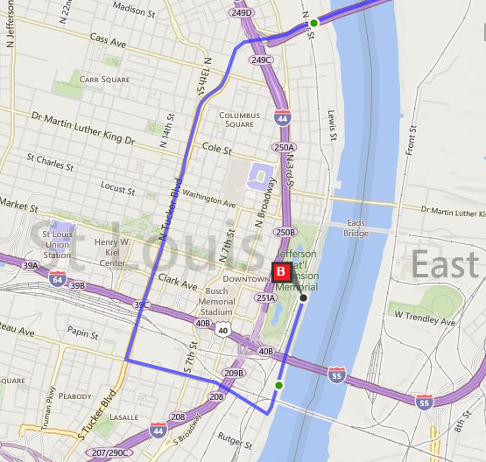

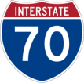

**From Illinois: Stan Musial Veterans Memorial Bridge**

Heading WEST on the Stan Musial Veterans Memorial Bridge, take the LEFT exit for N. Tucker Blvd Continue SOUTH on Tucker Blvd then turn LEFT on Chouteau. Continue EAST on Chouteau for 0.8 miles to the flood wall then turn LEFT on Leonor K. Sullivan Blvd at the T. Continue NORTH on Leonor K. Sullivan Blvd, past Poplar Street to enter Levee Parking.

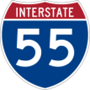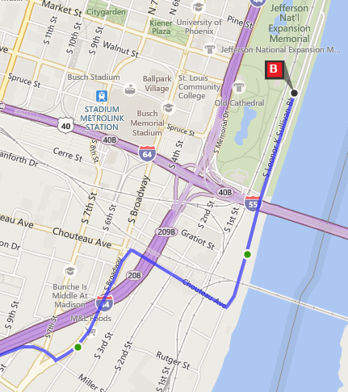

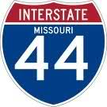

**From Missouri: Interstates 55 Northbound & 44 Eastbound**

Heading NORTH on I-55/East on I-44, take exit 290C for Park Ave. Turn RIGHT off of the exit onto Park Ave, then turn LEFT onto S. Broadway. Continue NORTH then turn RIGHT onto Chouteau Ave. Continue EAST on Chouteau to the flood wall then turn LEFT on Leonor K. Sullivan Blvd at the T. Continue NORTH on Leonor K. Sullivan Blvd, past Poplar Street to enter Levee Parking.

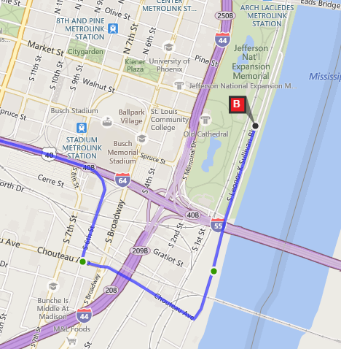

**From Missouri: Interstate 64/40 Eastbound**

Heading EAST on I-64, take Exit 40 – the “Last Missouri Exit” – to South 6th Street. Continue STRAIGHT off of the exit on 6th street. Turn LEFT on Chouteau Ave. Continue EAST on Chouteau to the flood wall then turn LEFT on Leonor K. Sullivan Blvd at the T. Continue NORTH on Leonor K. Sullivan Blvd, past Poplar Street to enter Levee Parking.

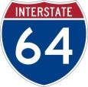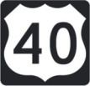

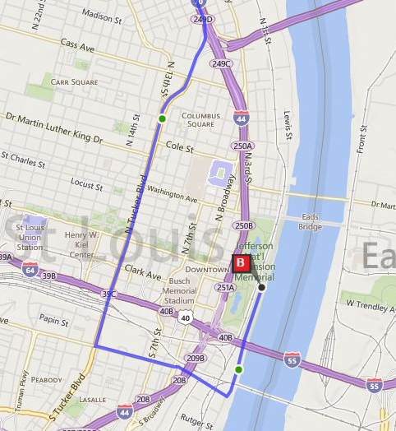



**From Missouri: Interstate 70 Eastbound**

Heading EAST on I-70, take Exit 249B for Tucker Blvd. Continue SOUTH on Tucker Blvd. then turn LEFT on Chouteau. Continue EAST on Chouteau for 0.8 miles to the flood wall then turn LEFT on Leonor K. Sullivan Blvd at the T. Continue NORTH on Leonor K. Sullivan Blvd, past Poplar Street to enter Levee Parking.

**Leaving Levee Parking on the Riverfront:**

For all interstates, continue SOUTH on Leonor K. Sullivan Blvd. and turn RIGHT on Chouteau.

For **I-70 West/I-44 East**, turn right onto 4th Street (heading north) then follow signs. For **I-64 West**, turn right onto 4th street, left onto Spruce, left onto Broadway, then follow signs. For **I-64 East**, turn right on 6th Street and follow signs. For **I-55 South**, and **I-44 West**, turn right on 4th Street, right on Spruce Street then follow signs.